CPE301 – SPRING 2019

Midterm1

Student Name: Kyungseo Yun

Student #: 2001091216

Student Email: yunk93@unlv.nevada.edu

Primary Github address: <https://github.com/biscuit0x/submission_yun.git>

Directory: submission_yun/DesignAssignments/midterm1/

Submit the following for all Labs:

1. In the document, for each task submit the modified or included code (only) with highlights and justifications of the modifications. Also, include the comments.
2. Use the previously create a Github repository with a random name (no CPE/301, Lastname, Firstname). Place all labs under the root folder ESD301/DA, sub-folder named LABXX, with one document and one video link file for each lab, place modified asm/c files named as LabXX-TYY.asm/c.
3. If multiple asm/c files or other libraries are used, create a folder LabXX-TYY and place these files inside the folder.
4. The folder should have a) Word document (see template), b) source code file(s) and other include files, c) text file with youtube video links (see template).

1. Components :

atmega328

jumper wires

esp8366

serial to usb module

DHT11 humidity&temperature sensor (broke my LM35 sensor)

2. C code

#define F_CPU 16000000UL

#define BAUDRATE 115200

#define BAUD_PRESCALAR (((F_CPU / (BAUDRATE * 16UL))) - 1)

#include <avr/io.h>

#include <avr/interrupt.h>

#include <stdio.h>

#include <stdlib.h>

#include <util/delay.h>

void set_timer(void); //timer initialization

void adc_init(void); //adc initialization

void read_adc(void); //read temperature

void AT_init(void); //esplorer set up

void USART_init(void); //USART functions

void USART_sendChar(char ch);

void USART_sendString(char* str);

volatile int adc_temp;

int main(void)

{

USART_init(); // initialize USART

AT_init(); // initialize AT setttings

set_timer(); // initialize Timer/Interrupt

adc_init(); // initialize ADC

while (1) // Loop forever

{

}

}

ISR (TIMER1_OVF_vect) {

read_adc(); //get temp

char temp[50];

snprintf(temp,sizeof(temp),"%d\r\n",adc_temp); //read into temp buffer

USART_sendString("AT+CIPSTART=\"TCP\",\"api.thingspeak.com\",80\r\n"); //connect to thingspeak

_delay_ms(3000);

USART_sendString("AT+CIPSEND=50\r\n"); //send 50 characters

_delay_ms(1000);

USART_sendString("GET /update?key=W7PJEYOYV6BGU372&field1="); //channel key

USART_sendString(temp); //send temperature

_delay_ms(1000);

USART_sendString("AT+CIPCLOSE\r\n"); //end

_delay_ms(1000);

TCNT1 = 0; //reset

}

void read_adc(void) {

unsigned char i =4;

adc_temp = 0; //initialize

while (i--) {

ADCSRA |= (1<<ADSC);

while(ADCSRA & (1<<ADSC));

adc_temp+= ADC;

_delay_ms(50);

}

adc_temp = adc_temp /4; //get average

}

void set_timer(void) {

TCNT1 = 0; //reset timer1

TIMSK1 |= (1 << TOIE0); //Enable Timer1 Interrupt

sei(); //Enable Global Interrupt

TCCR1B |= (1<<CS12)|(1<<CS10); //prescaler = 1024

}

void USART_init( void )

{

UBRR0H = 0;

UBRR0L = 8; // BAUD 115200

UCSR0C = _BV(UCSZ01) | _BV(UCSZ00); /* 8-bit data */

UCSR0B = _BV(RXEN0) | _BV(TXEN0); /* Enable RX and TX */

}

void USART_sendChar(char ch) {

//wait until UDR0 is empty

while (!(UCSR0A & (1<<UDRE0)));

UDR0 = ch; ; //transmit ch

}

void USART_sendString(char* str) {

while ((*str != '\0')) {

while (!(UCSR0A & (1<<UDRE0))); //wait until UDR0 is empty

USART_sendChar(*str); //transmit ch

str++;

}

}

void adc_init(void) {

ADMUX |= (0<<REFS1)| // Reference Select

(1<<REFS0)| // Selected AVcc

(0<<ADLAR)| // Left Adjust Result OFF

(1<<MUX2) | // Analog Channel Select

(0<<MUX1) | // 1 0 1

(1<<MUX0) ; // Channel 5 or PC5

ADCSRA |= (1<<ADEN)| // Enable ADC

(0<<ADSC)| // Do not start conversion

(0<<ADATE)|// Auto Trigger Disabled

(0<<ADIF)| // Interrupt Flag Cleared

(0<<ADIE)| // Interrupt Disabled

(1<<ADPS2)| // ADC Prescaler Select

(0<<ADPS1)| // Set to

(1<<ADPS0); // 32

}

void AT_init(void) {

USART_sendString("AT\r\n"); // Sends AT, expect OK

_delay_ms(1000);

USART_sendString("AT+CWMODE=1\r\n"); // Sends mode set to station, expect OK

_delay_ms(1000);

USART_sendString("AT+CWLAP\r\n"); // Send command to list Wifi networks, expect list

_delay_ms(4000);

USART_sendString("AT+CWJAP=\"Yun\",\"st980204\"\r\n"); // Send command to join guest wifi, expect OK

_delay_ms(3000);

}

3. Schematic

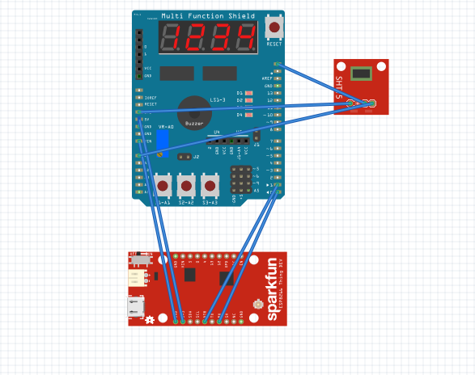

4. Screenshot

Atmel studio :

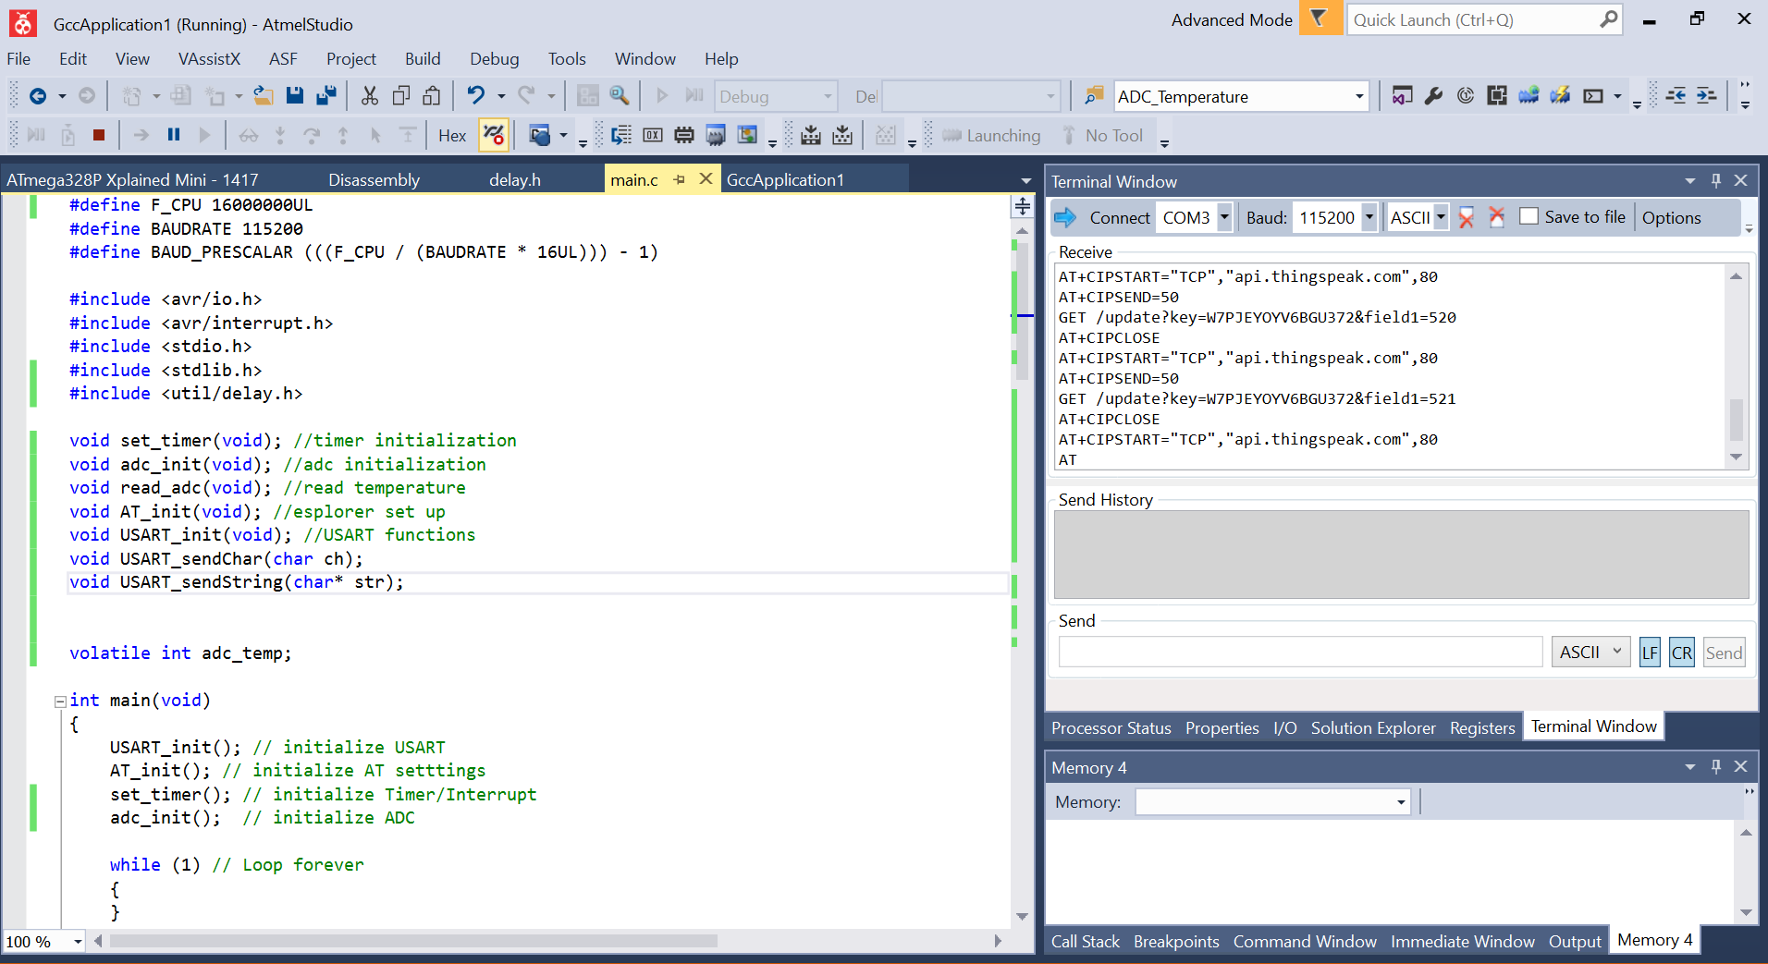

Esplore :

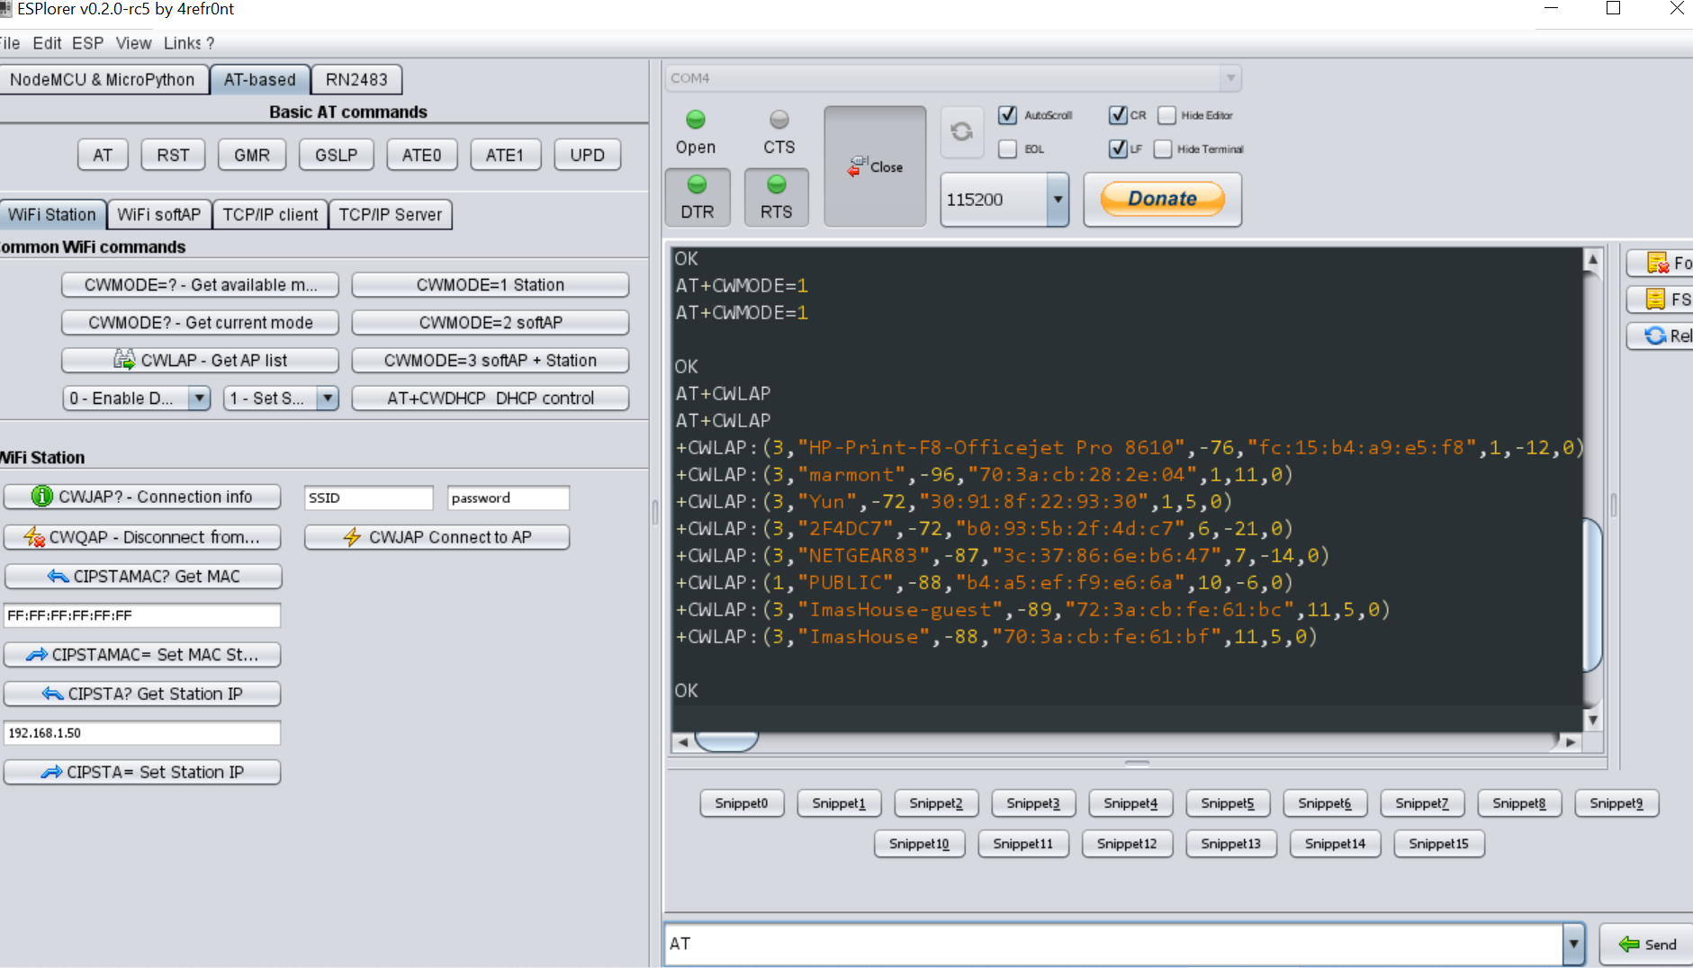

Thingspeak :

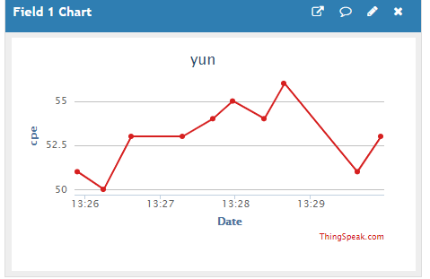

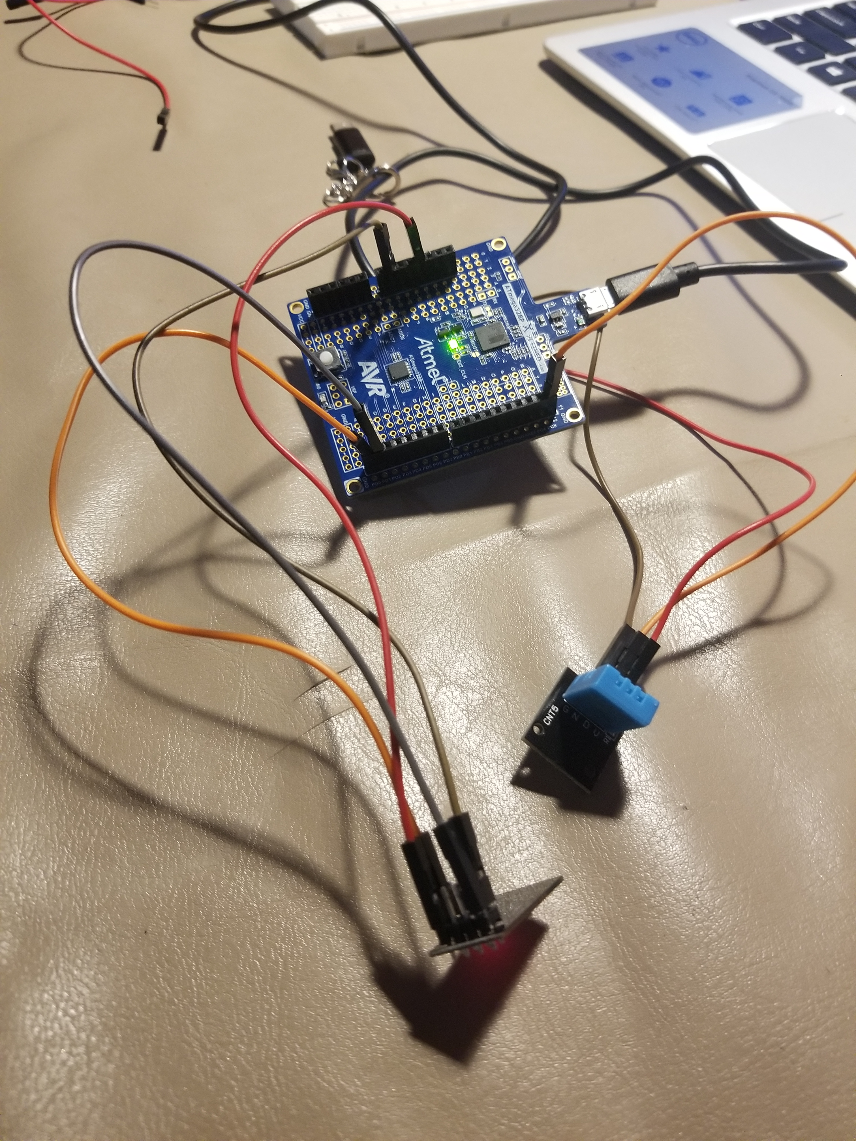5. Photo / video

(broke LM35 sensor, so used DHT11 humidity&temperature sensor)

<https://youtu.be/3dKTiEkg02E>